**Rubick Cube Game Project**

A SYNOPSIS on

Major Project (BCA-605)

Submitted in partial fulfillment of the requirements for the award of the degree of

BACHELOR OF COMPUTER APPLICATION

SUBMITTED BY

Name: Sagar Goswami

University Roll No.: 200845106059

Batch (2020-23)

Session (Even, 2022-23)

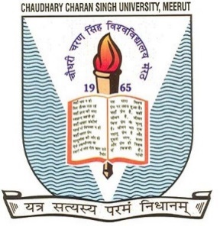

Ch. Charan Singh University, Meerut

Uttar Pradesh, INDIA

**Under the Supervision of**

Mrs. Teena Yadav

Associate / Assistant Professor

